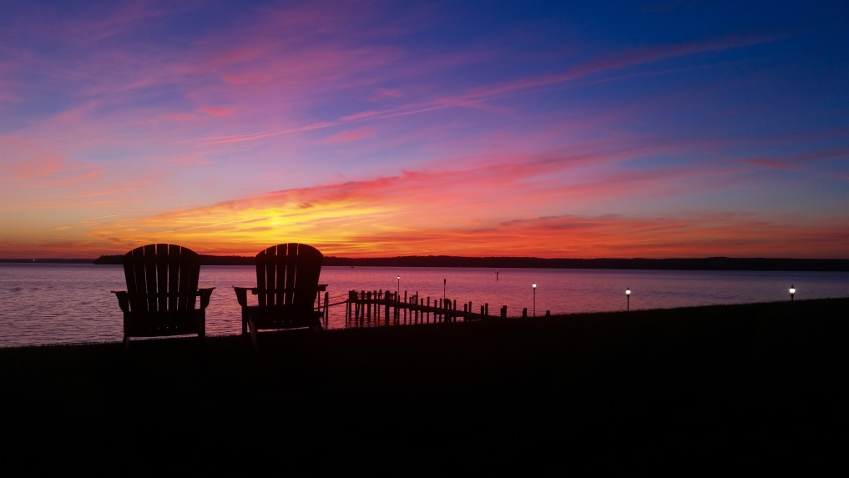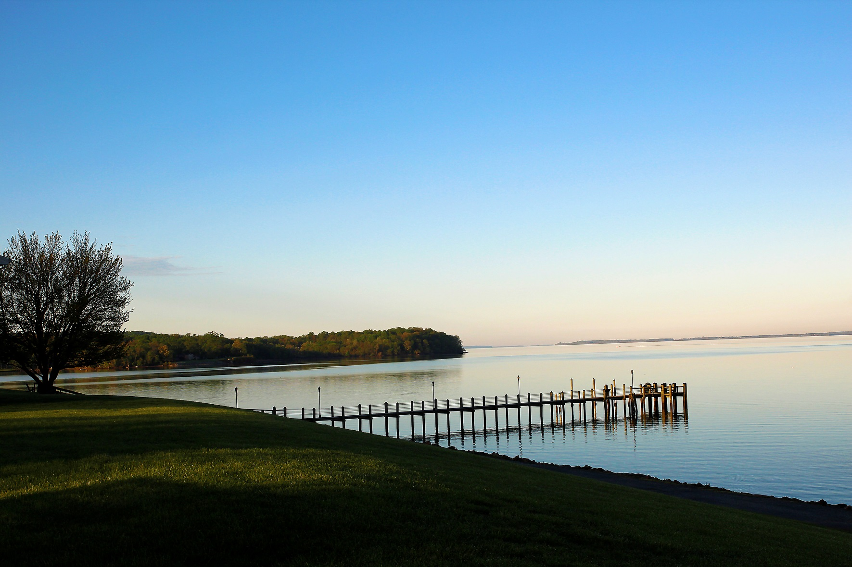

With [Names of Special Guests - Speaker / Worship Leader]

To register: [sign up at table in church foyer]

For more information: call [name and phone number] or email [name and email]

What to bring: Bible, notebook, modest one-piece swimsuit, etc.

Use this space for your specific retreat information

Use this space for your specific retreat information

With [Names of Special Guests - Speaker / Worship Leader]

To register: [sign up at table in church foyer]

For more information: call [name and phone number] or email [name and email]

What to bring: Bible, notebook, modest one-piece swimsuit, etc.

Join us at Sandy Cove for [Name of Your Event]

Join us at Sandy Cove for [Name of Your Event]

Organization name

Street

City, State Zip

Helping you connect with God and each other!

City, State Zip

Street

Organization name

Helping you connect with God and each other!